**UC 1: Register**

|  |  |
| --- | --- |
| **Precondition: System does not have a registered account in Squirrel (UTA mobile vending system) for “Student/Staff”.**  **Note: Registration process is the same for all three system users.** | |
| **Actor: System User** | **System: Squirrel** |
|  | 0.System Displays the Application LogIn screen (figure 1)**.** |
| **1. TUCBW** The System User selects the Registration function on Application LogIn screen. | 2.System Displays the registration form in registration screen (figure 2). |
| 3.System user fills the details and selects register. | *4.System displays successful message ‘Registered’ (figure 3) and user is redirected back to Application LogIn screen (figure 3). |
| **5.TUCEW** System user sees the successful message ‘Registered’ and sees the return to the Application LogIn screen. |  |
| **Post condition: The system creates a new account for the system user in the system. (Here is for Student/ Staff/ non student).** | |

Figure 1 Figure 2 Figure 3

**UC 2: Login**

|  |  |
| --- | --- |
| **Precondition: System has account in Squirrel (UTA mobile vending system) for the system user (General Role, applied to all users).** | |
| **Actor: System User** | **System: Squirrel** |
|  | 0.System Displays the Application LogIn screen (figure 4)**.** |
| **1. TUCBW** The System User enters the username, password and selects Login. | *2.System Displays the different system user Home screen based on role selected in registration screen.  (i) student / staff/ non student will be shown Home screen (figure 5).  (ii) operator will be shown Home screen (figure 6).  (iii) Manager will be shown Home screen (figure 7). |
| **3.TUCEW** System user gains access into the system. System user see their functions based on the role. |  |
| **Post condition: The system directs the user to his/her home screen where he/she is eligible to access appropriate user functions based on the role.** | |

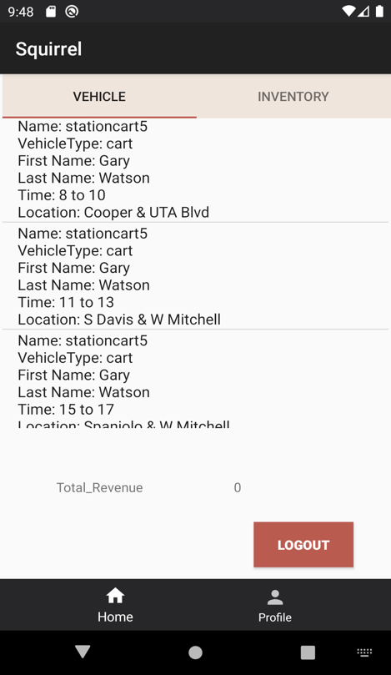

Figure 4 Figure 5 Figure 6

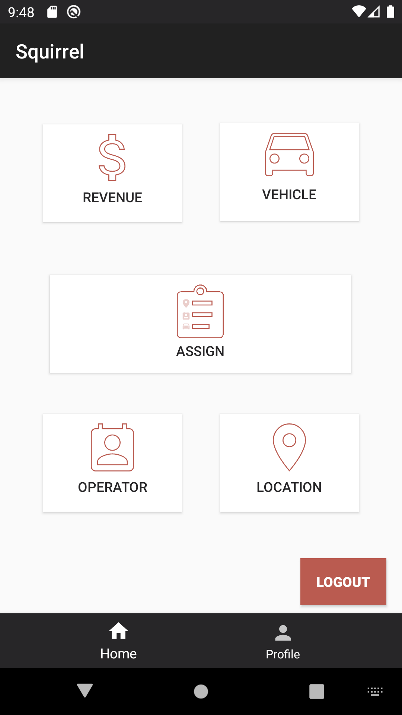

Figure 7

**UC 2.1: Forgot Password? (Reset Password)**

|  |  |
| --- | --- |
| **Precondition: System has the user’s account in the application. (General Role, applied to all users).** | |
| **Actor: System User** | **System: Squirrel** |
|  | 0.System Displays the Application LogIn screen (figure 8)**.** |
| **1. TUCBW** The System User selects forgot password function to reset the password. | 2.System Displays the conformation email address screen. (figure 9) |
| 3. The user enters his/her email address and conform the email address. | *4. System displays enter new password to the user. (figure 10) |
| **5.TUCEW** User enters his/her new password to update the information. And the user will be return to the login screen. |  |
| **Post condition: The system directs the user to login screen and updates the password in the system.** | |

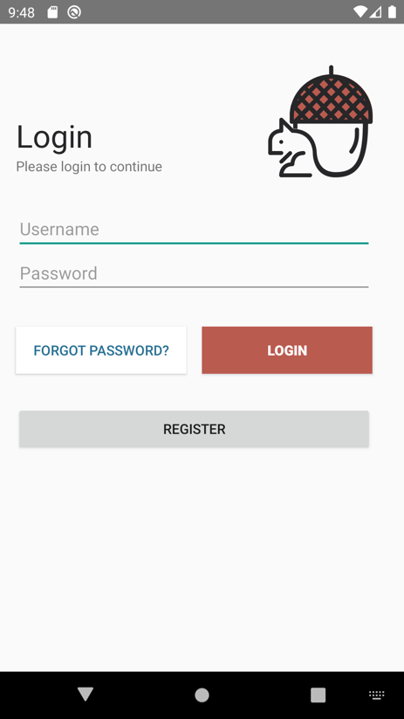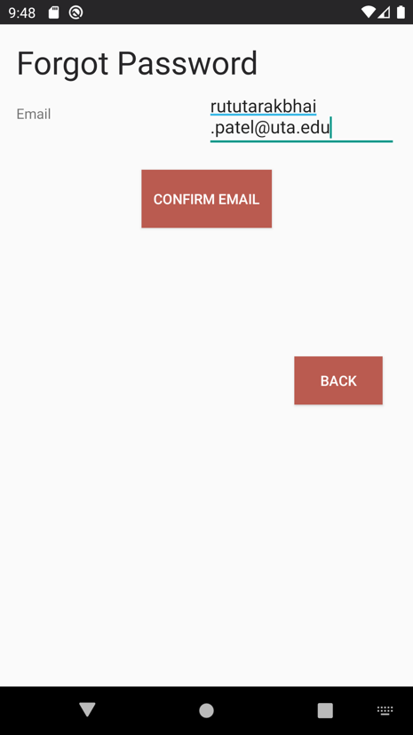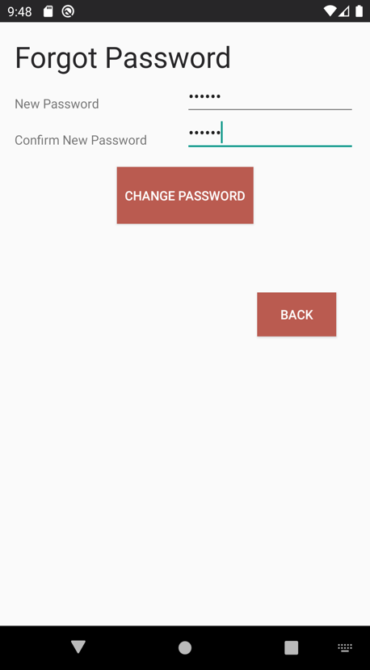

Figure 8 Figure 9 Figure 10

**UC 3: Logout**

|  |  |
| --- | --- |
| **Precondition: The system shows the system user (general for all roles) as already logged in into the application.** | |
| **Actor: System User** | **System: Squirrel** |
|  | 0.System Displays certain page. (figure 11)**.** (Logout is accessible from all screens) |
| **1. TUCBW** The System User selects Logout from his/ her current screen. | 2.System displays successful message ‘Logout Successful’ and user is redirected back to the application’s LogIn screen (figure 12). |
| **3.TUCEW** System user sees the application Login screen. |  |
| **Post condition: The system logs out the system user from the Squirrel app (UTA mobile vending system). (General for all users)** | |

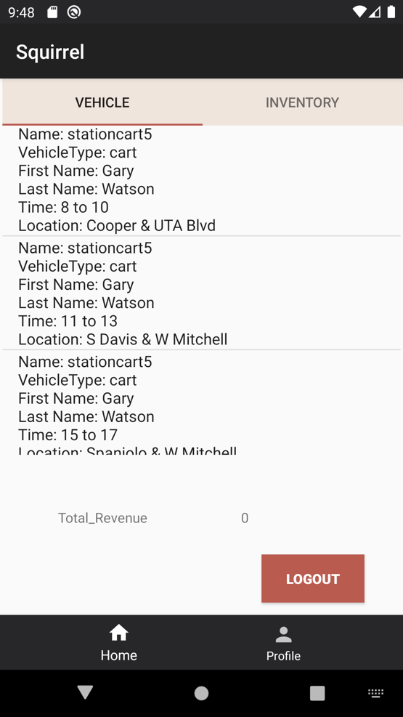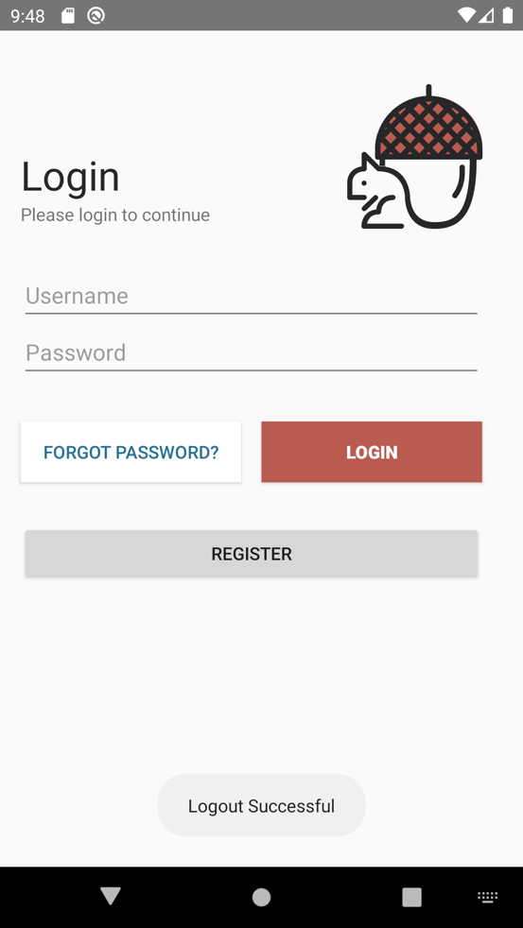

Figure 11 Figure 12

**UC 4: View Profile**

|  |  |
| --- | --- |
| **Precondition: The system shows system user as already logged in. (General for all users)** | |
| **Actor: System User** | **System: Squirrel** |
|  | 0.System Displays the screen with bottom navigation bar which contain profile function. (Bottom navigation is accessible from all screens) |
| **1. TUCBW** The System User selects profile (profile function) from bottom navigation bar. | *2.System displays all the user’s information in view profile screen. (figure 13).  (i) Student/ Staff/ non students users have more unique functions presented in their profile screen, such as add card information. (figure 14). |
| **3.TUCEW** System user sees his/ her information. User can return to the application Home screen (unique based on the role) through the bottom navigation. |  |
| **Post condition: The system displays the profile of the logged in user. (General for all users)** | |

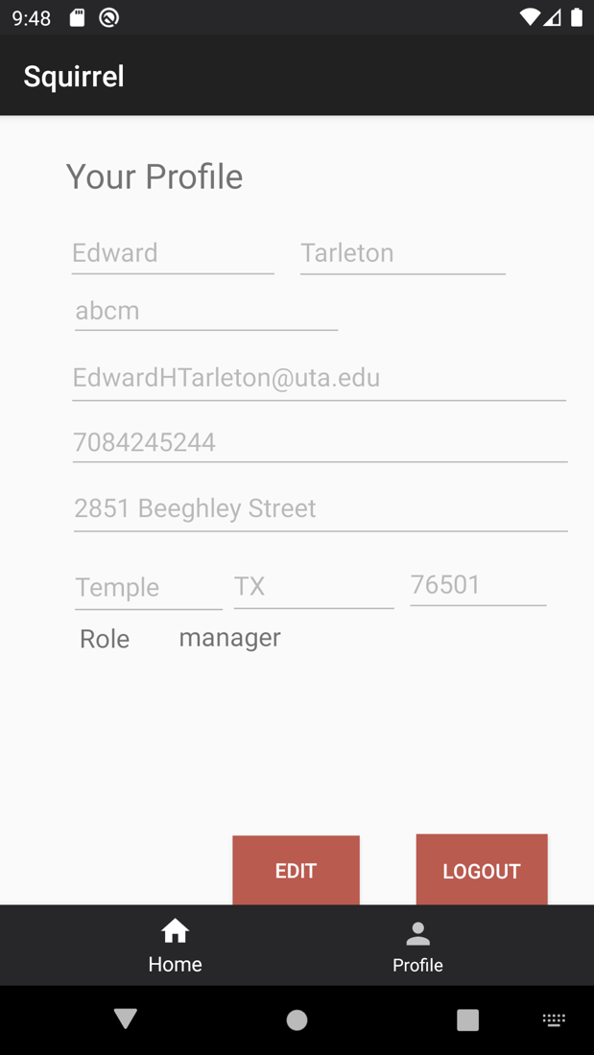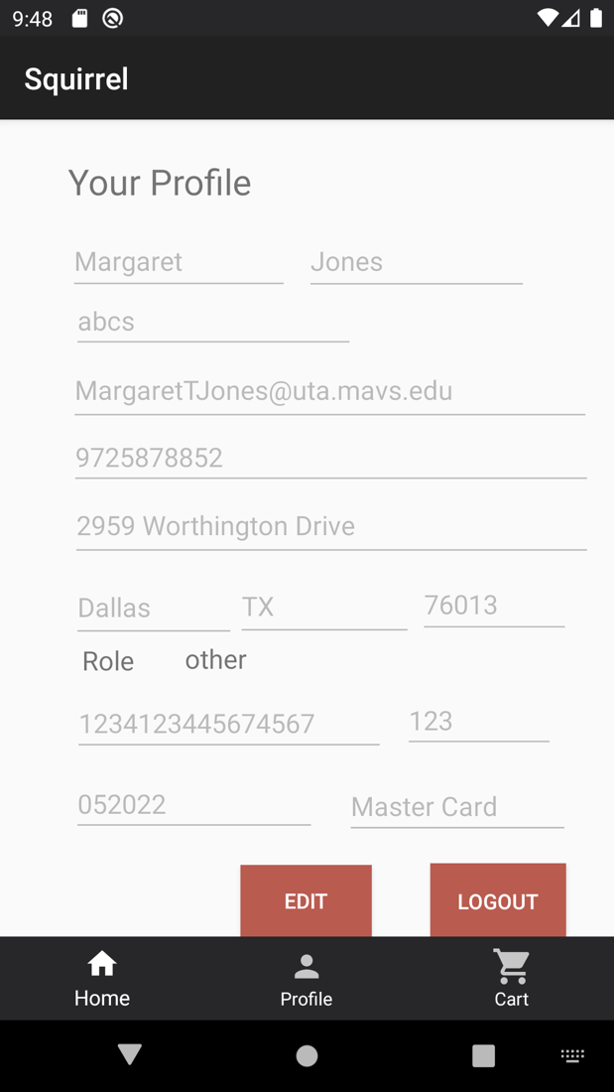

Figure 13 Figure 14

**UC 5: Update Profile**

|  |  |
| --- | --- |
| **Precondition: The system shows system user as logged in. (General for all users)** | |
| **Actor: System User** | **System: Squirrel** |
|  | 0.System Displays the view profile screen (figure 15). |
| **1. TUCBW** The System User update one or more fields (after clicking on edit button) and selects update profile. | *2.System updated the user profile with new values and displays the successful message ‘Updated Successfully’ (figure 16). |
| **3.TUCEW** System user see successfully update profile message. The user can return to the application home screen through the bottom navigation. |  |
| **Post condition: The system will update the values of the logged in system user. (General for all users)** | |

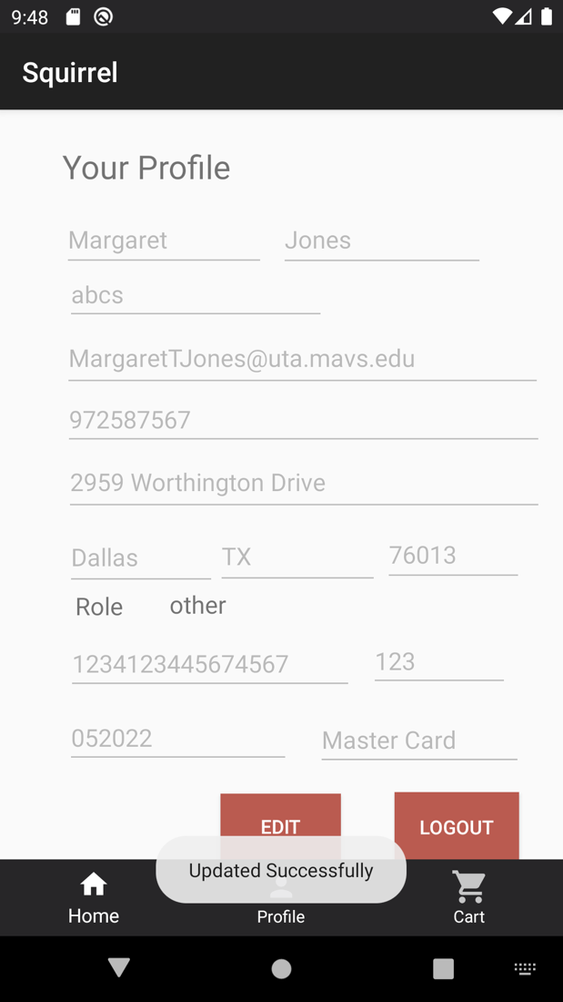

Figure 15 Figure 16

**UC 6: View List of Vehicles**

|  |  |
| --- | --- |
| **Precondition: The system shows student/ staff/ non student as already logged in.** | |
| **Actor: student/ staff/ non student** | **System: Squirrel** |
|  | 0.System displays the home screen (figure 18). |
| **1. TUCBW** The user can navigate through top bar navigation to switch between Food Truck list of vehicles or Food Cart list of vehicles. | *2.System displays the list of available vehicles based on the active tab. (Vehicle Name, Vehicle Type, Location,  Beginning and Ending Time).  (i) Student/ Staff/ non students users have tapped on Food Truck bar. System displays list of available Food Trucks. (figure 19).  (ii) Student/ Staff/ non students users have tapped on Food Cart bar. System displays list of available Food Carts. (figure 20). |
| **3.TUCEW** System user can view list of available vehicles successfully. And user can navigate back to the home screen from bottom navigation. |  |
| **Post condition: The system displays list of available vehicles for the actor.** | |

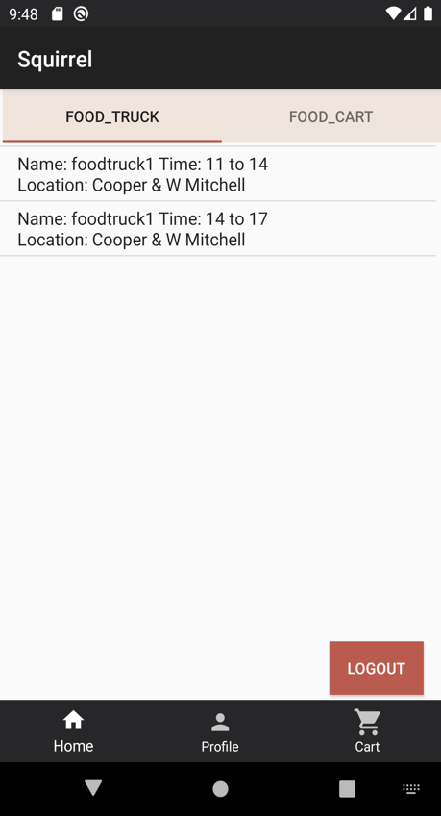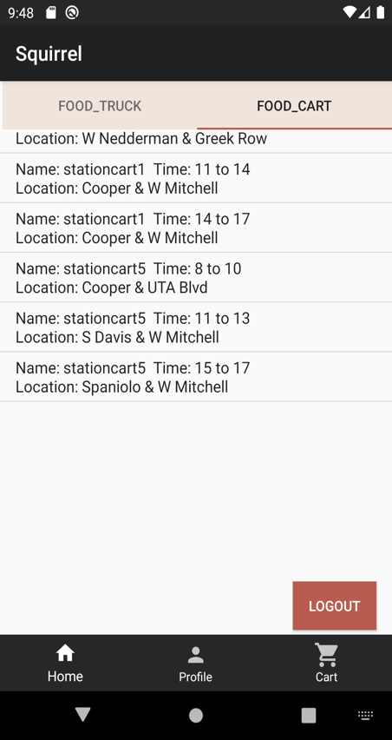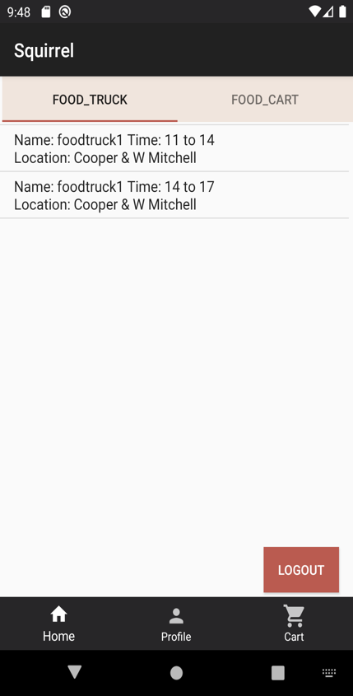

Figure 18 Figure 19 Figure 20

**UC 7: View Inventory**

|  |  |
| --- | --- |
| **Precondition: The system shows student/ staff/ non student as already logged in.** | |
| **Actor: student/ staff/ non student** | **System: Squirrel** |
|  | 0. System displays the view list of vehicles screen based on the active tab (Food truck and food cart). (Vehicle Name, Vehicle Type, Location,  Beginning and Ending Time).  (figure 21). |
| **1. TUCBW** The user selects on the specific vehicle from the list of available food trucks and/or available food carts. | *2.System displays the list of available inventory based on the selected vehicle. (Item cost, item names, Item quantity).  (figure 22). |
| **3.TUCEW** System user can successfully see the view inventory screen and if choses, the user can return to the view list of vehicle screens from bottom navigation (through home icon). |  |
| **Post condition: The system displays list of available inventory for selected vehicle to the actor.** | |

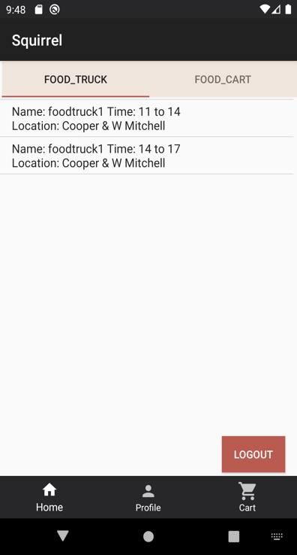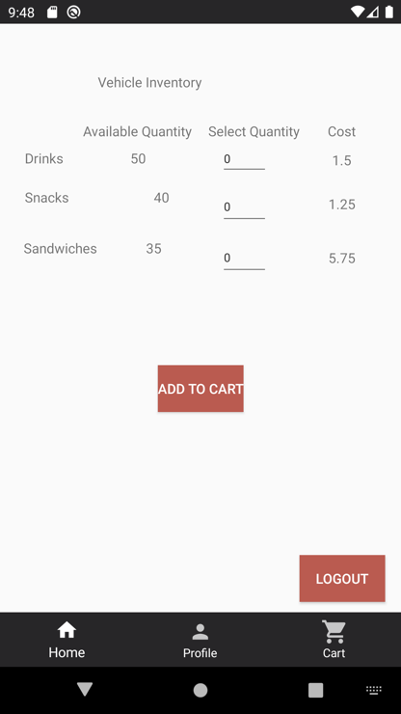

Figure 21 Figure 22

**UC 8: Add to Cart**

|  |  |
| --- | --- |
| **Preconditions:**  **-The system shows student/ staff/ non student as already logged in.**  **- The system is displaying the View Inventory screen for the chosen vehicle by user.** | |
| **Actor: student/ staff/ non student** | **System: Squirrel** |
|  | 0. System displays the view inventory screen (Item cost, item names, Item quantity). (figure 23). |
| **1. TUCBW** The user selects the quantity for desired the item type. | 2.System displays the updated quantity of items (figure 24). |
| 3.The user selects add to cart. | *4.System displays the successful message to the user “Item (Name) successfully added”. (figure 25). |
| **5.TUCEW** System user can successfully see the toast massage from the system that items has been add to the shopping cart. And user can navigate back to the home screen from bottom navigation. |  |
| **Post condition: The system adds the chosen items and their quantities for a specific vehicle to the cart.** | |
|  | |

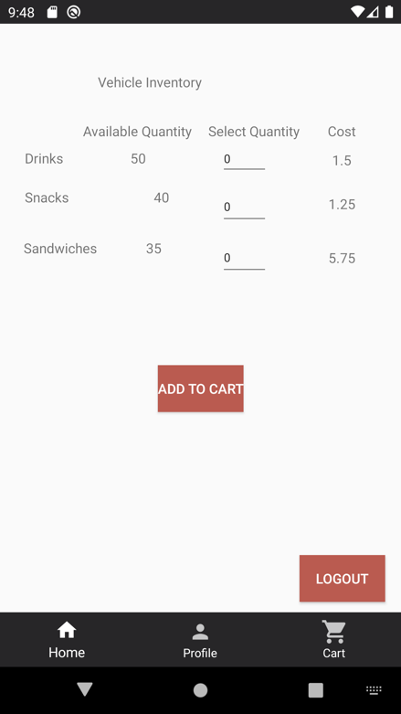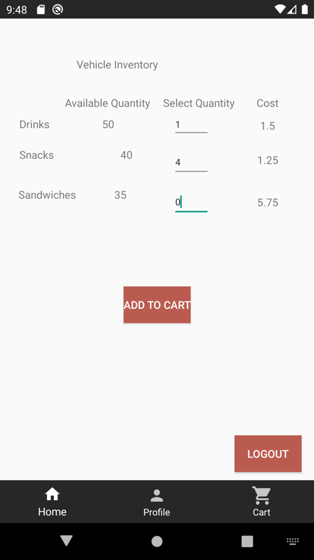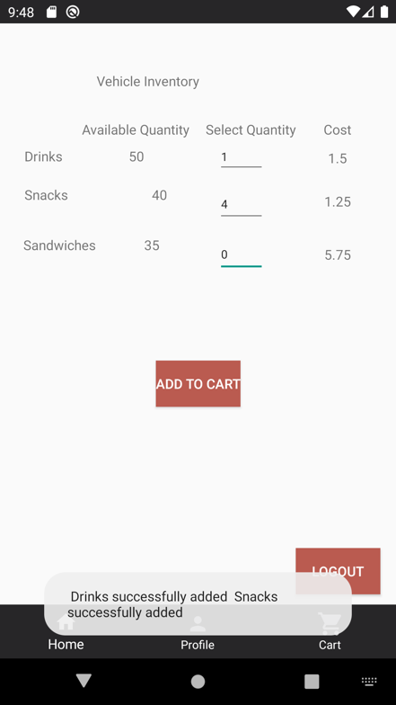

Figure 23 Figure 24 Figure 25

**UC 9: Modify/ View Cart**

|  |  |
| --- | --- |
| **Precondition:**  **-The system shows student/ staff/ non student as already logged in.**  **-The system captured the selected items/ quantities from the user and added to the cart functionality.** | |
| **Actor: student/ staff/ non student** | **System: Squirrel** |
|  | 0. System displays the home screen (view list of vehicle screen) for the user.  (figure 26). |
| **1. TUCBW** The user selects shopping cart (cart functionality) accessible from all screens through the bottom navigation bar. | 2.System displays the list of items added to the user’s cart including (item Name, item type, quantity for each item, cost per item, total cost for all items) (figure 27). |
| 3. The user sees the items in the cart successfully. The user can modify one or more fields in their cart (remove and item, update quantity). | *4. The system display the updated cart information (if any update has been done by the user).  (figure 28) |
| **5.TUCEW** User can successfully see the updated shopping cart. User can go to checkout screen or navigate back to home screen (view list of vehicle) from the bottom navigation bar. |  |
| **Post condition: The system will update the cart values based on user’s input. And display the most updated result to the user.** | |

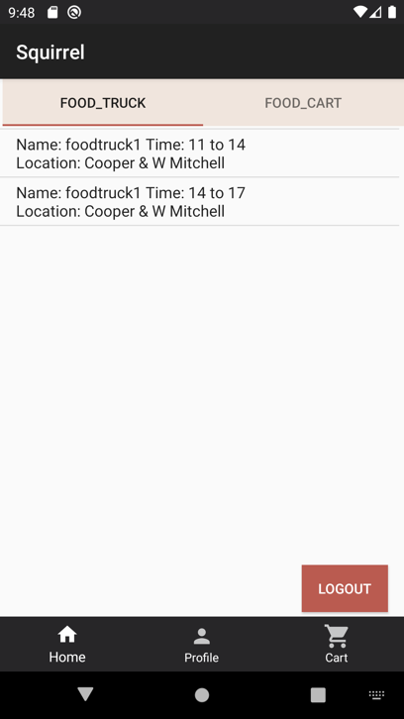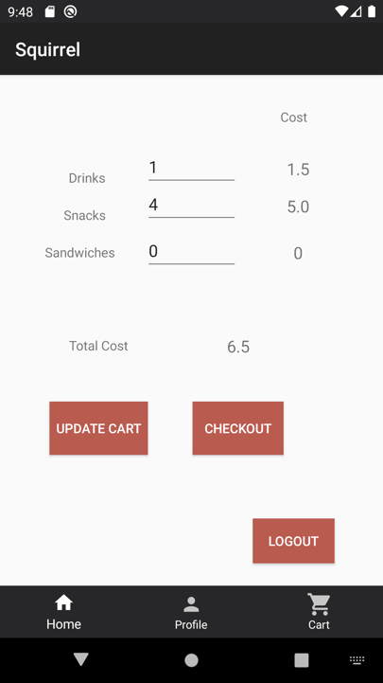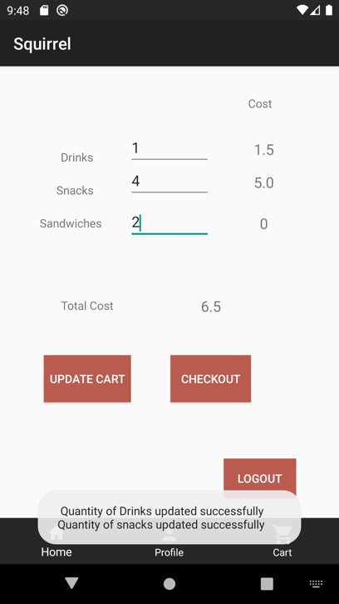

Figure 26. Figure 27 Figure 28

**UC 10: View List of Vehicles**

|  |  |
| --- | --- |
| **Precondition: The system shows the actor as already logged in.** | |
| **Actor: Manager** | **System: Squirrel** |
|  | 0. System displays the home screen for the user.  (figure 29). |
| **1. TUCBW** The user select the vehicle icon (function) from the home screen. | *2.System displays the list of items added to the user’s cart including (Vehicle Name, Vehicle type, Operator First Name, Operator Last Name, Location, Schedule Date, Slot Begin, Slot End)  (figure 30). |
| **3.TUCEW** User can successfully see the list of vehicles. And user can navigate back to the home screen from bottom navigation. |  |
| **Post condition: The system will display list of all vehicles.** | |

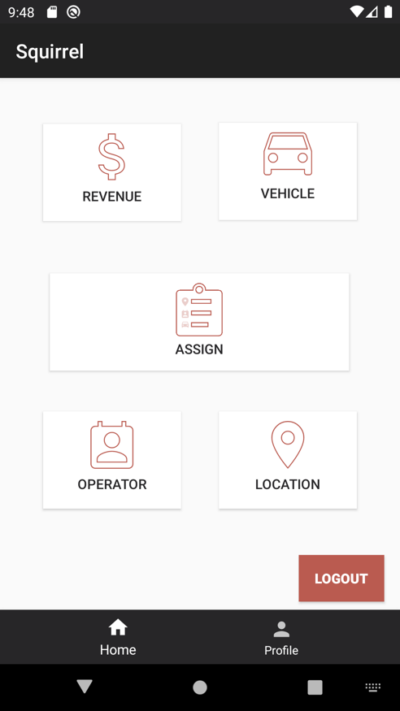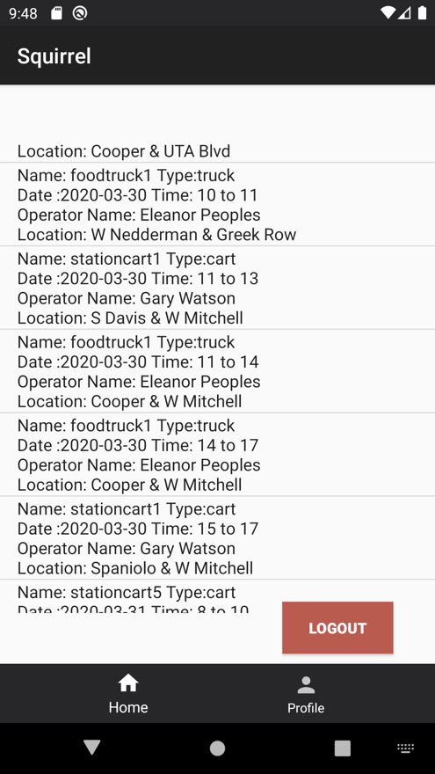

Figure 29 Figure 30

**UC 11: View/ Modify Vehicles Inventory**

|  |  |
| --- | --- |
| **Precondition:**  **-The system shows the actor as already logged in.** | |
| **Actor: Manager** | **System: Squirrel** |
|  | 0. System displays view list of vehicles screen.  (figure 31). |
| **1. TUCBW** The user select the vehicle of his choice. | 2.System displays the inventory for the selected vehicle on view/ modify vehicle inventory. (quantity, cost, item type)  (figure 32). |
| 3.User can update one or more fields (quantity and/ or cost) per item type. Or he can only view the list of inventory. | *4.System displays the inventory or in case of update, the updated inventory will be displayed. And it will generate a success toast. (figure 33). |
| **5.TUCEW** User can successfully see the updated inventory for the selected vehicle. User can navigate back to home screen through bottom navigation. |  |
| **Post condition: The system will update the inventory values and displays the updated inventory to the user for the selected vehicle.** | |

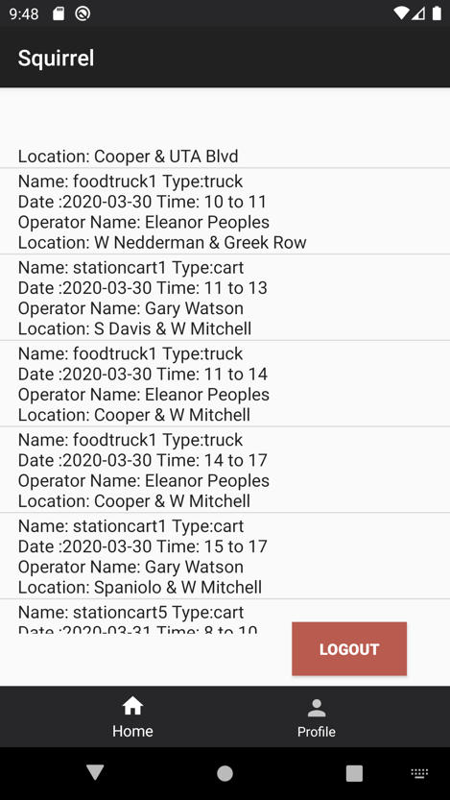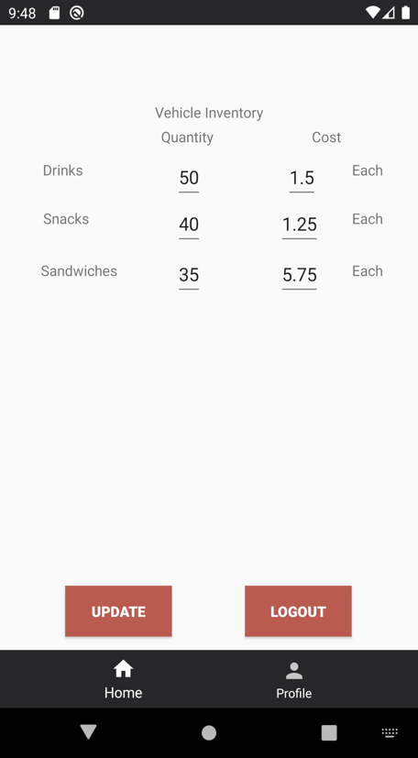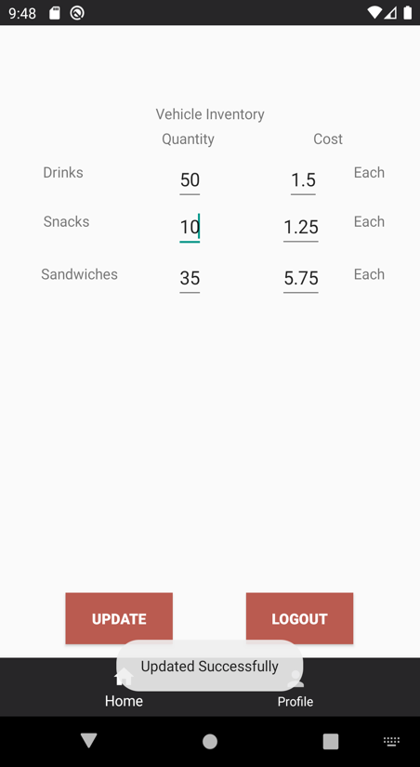

Figure 31 Figure 32 Figure 33

**UC 12: View Vehicle Revenue**

|  |  |
| --- | --- |
| **Precondition:**  **-The system shows the actor as already logged in.** | |
| **Actor: Manager** | **System: Squirrel** |
|  | 0. System displays home screen.  (figure 34). |
| **1. TUCBW** The user select the revenue function. | *2.System displays the revenue on view vehicle revenue screen. (Vehicle Name  , Operator First Name, Operator Last Name, Payment Date, Total Revenue (Per vehicle), Sum of revenue for all vehicles)  (figure 35). |
| **3.TUCEW** User can successfully see the revenue for each vehicle and sum of revenue for all vehicles together. And user can navigate back to the home screen from bottom navigation. |  |
| **Post condition: The system will display vehicle revenue to the user.** | |

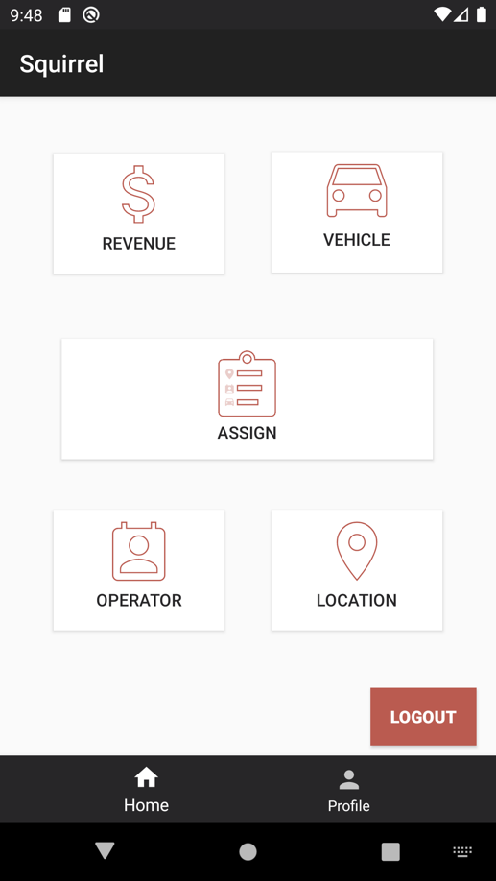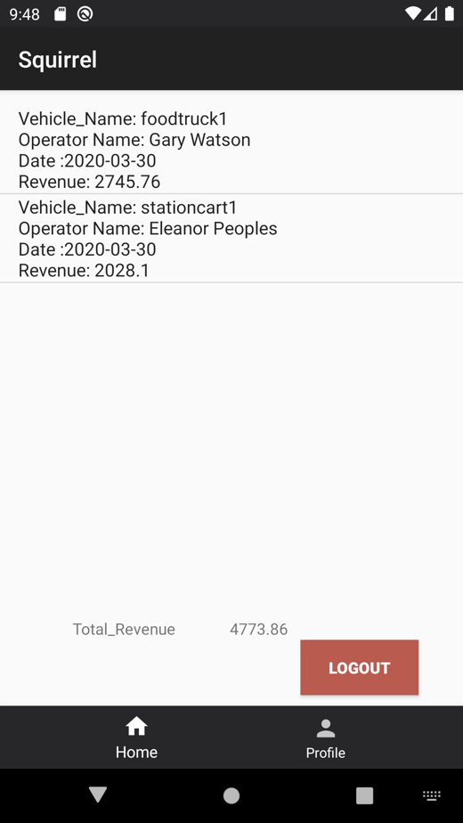

Figure 34 Figure 35

**UC 13: Assign Vehicles/ Location/ Operator/ Time Slot**

|  |  |
| --- | --- |
| **Precondition:**  **-The system shows the actor as already logged in.** | |
| **Actor: Manager** | **System: Squirrel** |
|  | 0. System displays home screen.  (figure 36). |
| **1. TUCBW** The user select the assign function. | 2.Systm displays the assign screen  (figure 37). |
| 3. User selects the vehicle from vehicle list, location from location list, operator from operator list, start time from the time list.(Drop down menu) | *4.System displays the selected vehicle (Vehicle Name, Vehicle Id), selected location (Location Id, Location Address, Duration), selected operator (Operator Id, Operator Name), selected start time (Start Time, End time (given by default to user)) (figure 38). |
| **5.TUCEW** User can successfully assign the chosen field if there is no conflict. The system will prompt user if the assign is successful or if it is invalid. And user can navigate back to the home screen from bottom navigation. |  |
| **Post condition: The system will display assigned information to the user and update the values in the system.** | |

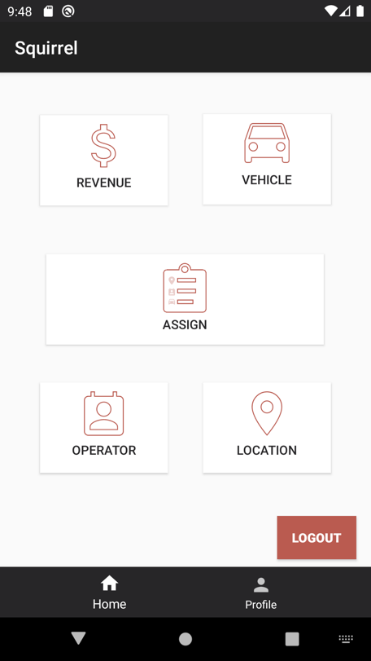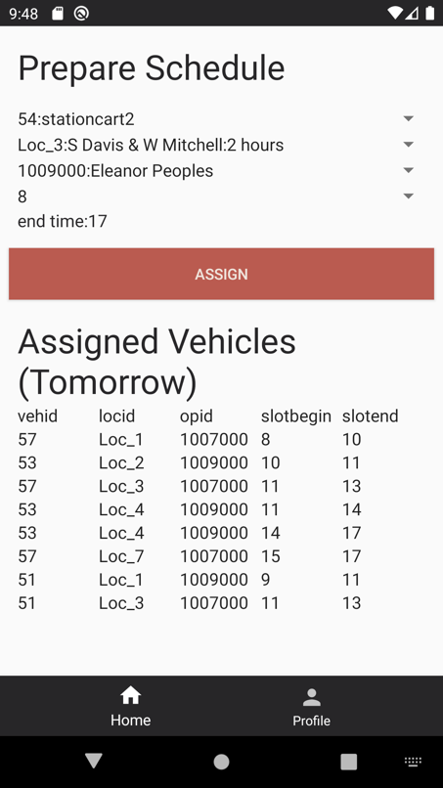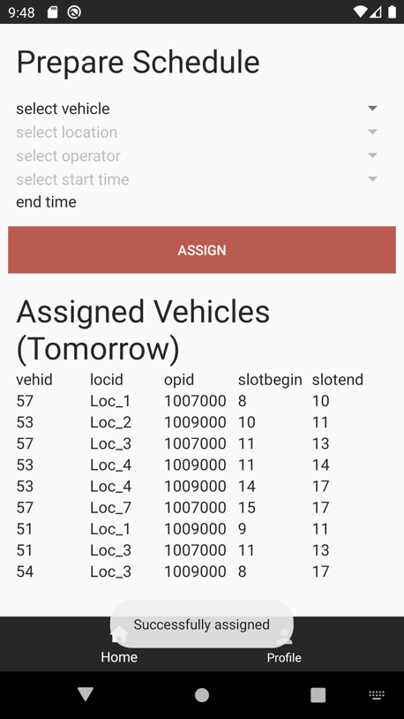

Figure 36 Figure 37 Figure 38

**UC 14: View Operator**

|  |  |
| --- | --- |
| **Precondition:**  **-The system shows the actor as already logged in.** | |
| **Actor: Manager** | **System: Squirrel** |
|  | 0. System displays home screen.  (figure 39). |
| **1. TUCBW** The user select the operator function. | 2.System displays the operator screen (Operators Names, Vehicle Name, Location, Slot End)  (figure 40). |
| **3.TUCEW** User can successfully see the list of assigned vehicles to every assigned operator with the time schedule information. And user can navigate back to the home screen from bottom navigation. |  |
| **Post condition: The system will display the list of assigned operators to their vehicles to the user.** | |

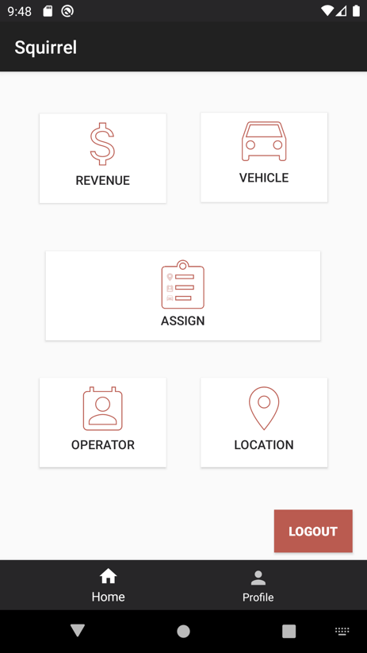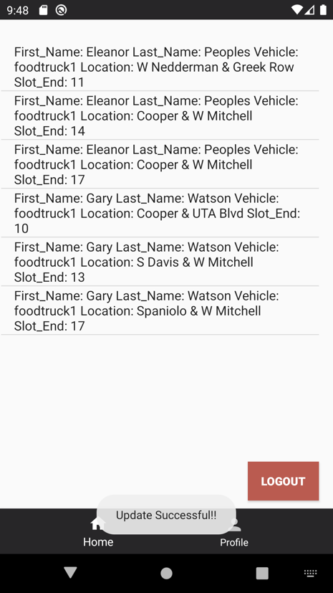

Figure 39 Figure 40

**UC 15: Modify Operator**

|  |  |
| --- | --- |
| **Precondition:**  **-The system shows the actor as already logged in.**  **- The system is displaying the View operator screen.** | |
| **Actor: Manager** | **System: Squirrel** |
|  | 0. System displays view operator screen (Operators Names, Vehicle Name, Location, Slot End) (figure 41). |
| **1. TUCBW** The user select the list item which he wants to change. | 2.System displays the modify operator screen (Operator fist and last name, vehicle name, location, slot end) (figure 42). |
| 3.User can select the vehicle from vehicle list and update. | *4.System displays the selected vehicle (vehicle id, vehicle name) and provide a success toast to the user. (figure 43). |
| **5.TUCEW** System user see successfully update profile message. And user can navigate back to the home screen from bottom navigation. |  |
| **Post condition: The system will display the updated values to the user and update in system** | |

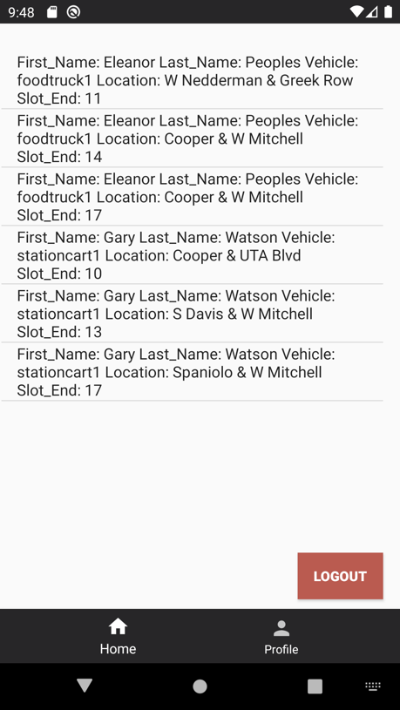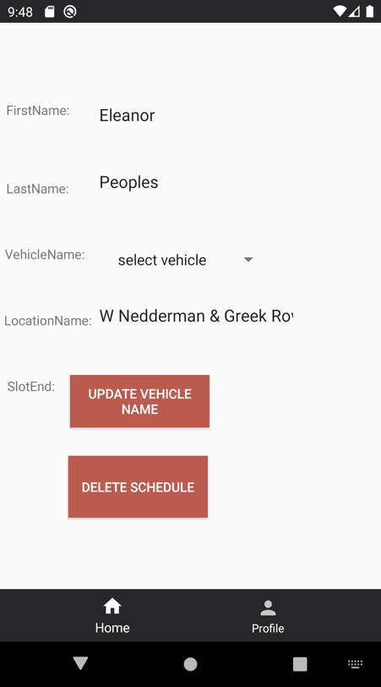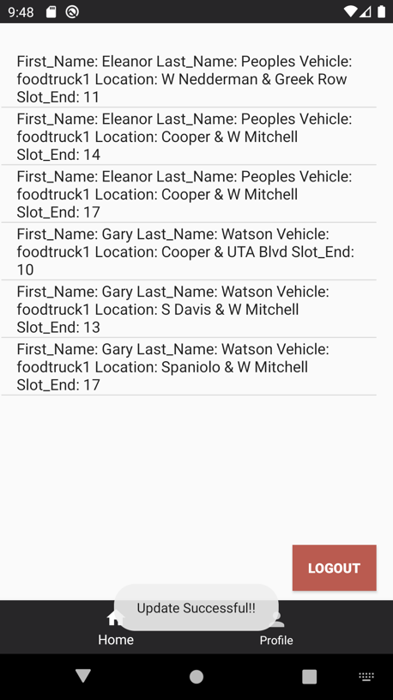

Figure 41 Figure 42 Figure 43

**UC 16: View Location**

|  |  |
| --- | --- |
| **Precondition:**  **-The system shows the actor as already logged in.** | |
| **Actor: Manager** | **System: Squirrel** |
|  | 0. System displays home screen.  (figure 44). |
| **1. TUCBW** The user select the location function. | *2.System displays the list of locations to the user. (Location ID, location Name, Duration.)  (figure 45). |
| **3.TUCEW** User can successfully see the list of locations. User can navigate back to home screen through bottom navigation. |  |
| **Post condition: The system will display all locations for the user.** | |

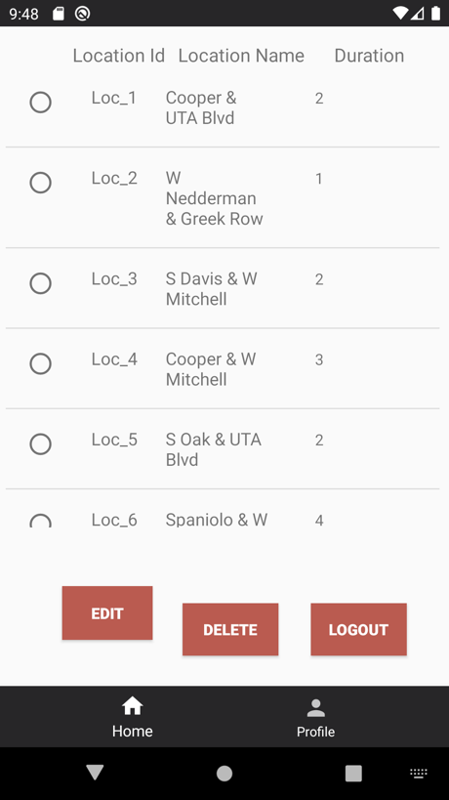

Figure 44 Figure 45

**UC 17: Modify Location**

|  |  |
| --- | --- |
| **Precondition:**  **-The system shows the actor as already logged in.** | |
| **Actor: Manager** | **System: Squirrel** |
|  | 0. System displays view location screen.  (figure 46). |
| **1. TUCBW** The user select one specific location to modify that location. | 2.System displays the modify location screen for the selected location. (Location Name, Duration)  (figure 47). |
| 3.User can modify the location’s name or the location duration. | *4.System displays updated information on that location and provide a success toast to the user. (figure 48). |
| **5.TUCEW** User can successfully see the updated location and by default will be navigate back to view location screen. And user can navigate back to the home screen from bottom navigation. |  |
| **Post condition: The system will update the location value for the selected location and displays the updated information to the location.** | |

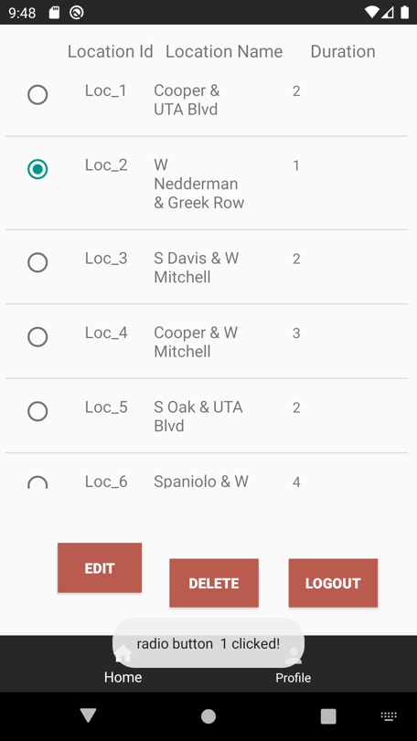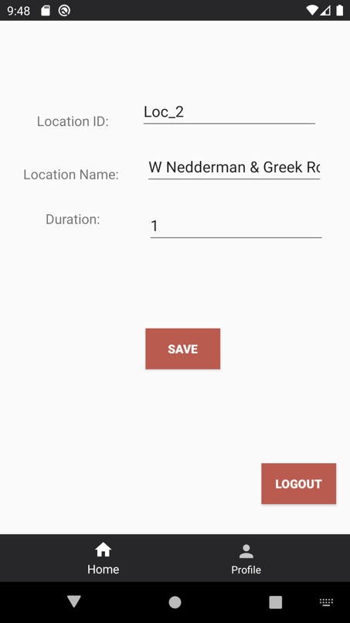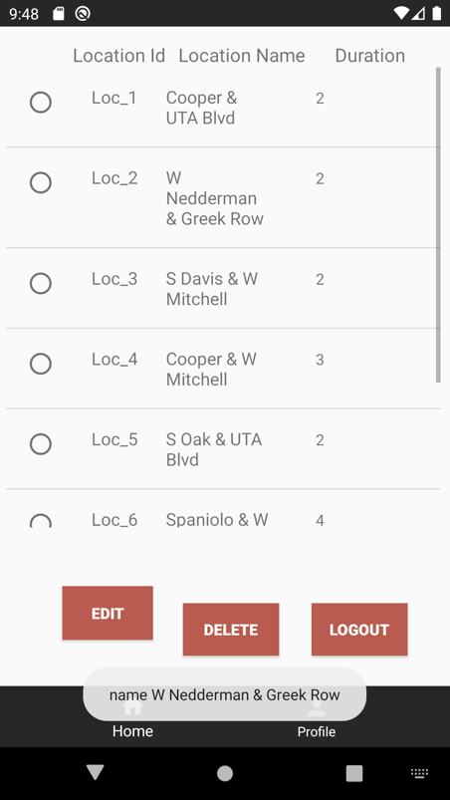

Figure 46 Figure 47 Figure 48

**UC 18: View/ Modify Vehicles Inventory**

|  |  |
| --- | --- |
| **Precondition:**  **-The system shows the actor as already logged in.** | |
| **Actor: Operator** | **System: Squirrel** |
|  | 0. System displays home screen  (figure 49). |
| **1. TUCBW** The user select the vehicle inventory from top bar. | 2.System displays the inventory for the assigned vehicle to operator vehicle on view/ modify vehicle inventory. (quantity, cost, item type)  (figure 50). |
| 3.User can update one or more fields (quantity) per item type. Or he can only view the list of inventory. | *4.System displays the inventory or in case of update, the updated inventory will be displayed. And it will generate a success toast. (figure 51). |
| **5.TUCEW** User can successfully see the updated inventory for the selected vehicle. User can navigate back to home screen through bottom navigation or top bar. |  |
| **Post condition: The system will update the inventory values and displays the updated inventory to the user for the selected vehicle.** | |

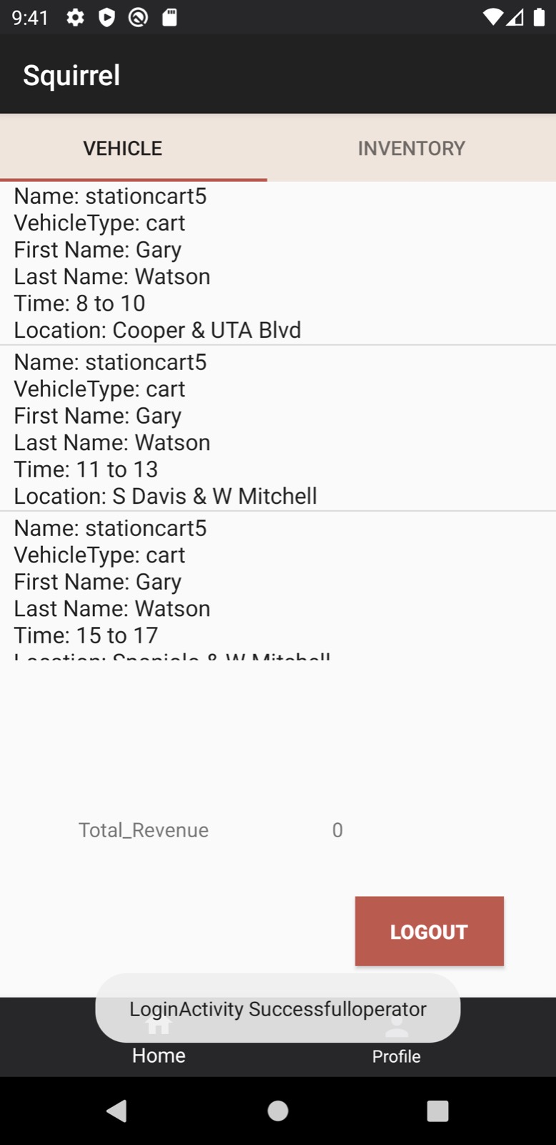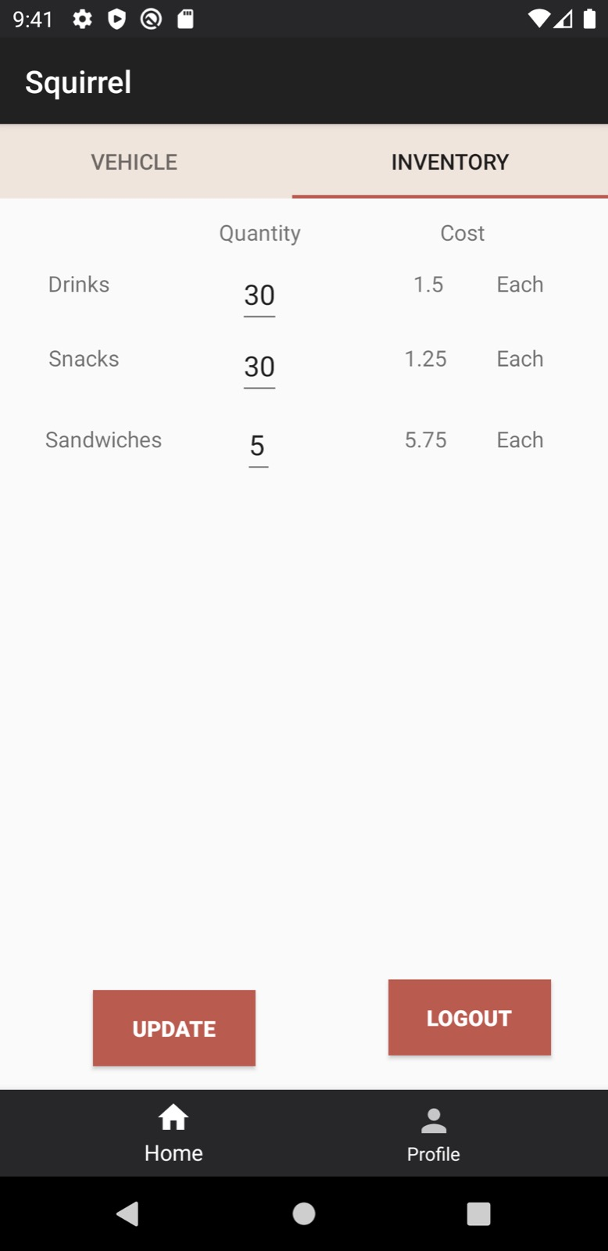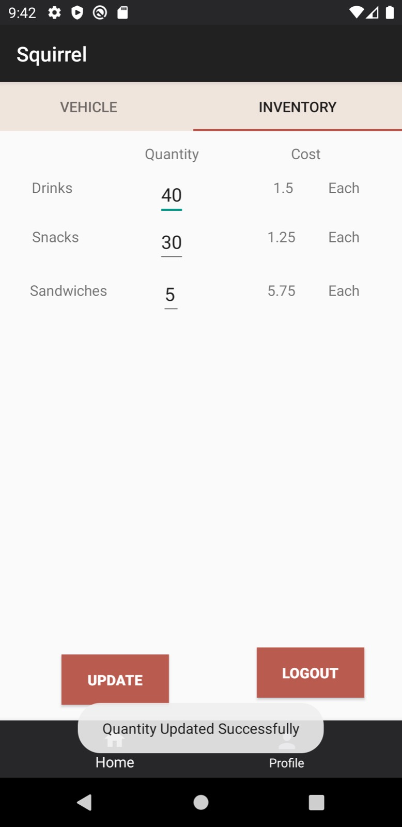

Figure 49 Figure 50 Figure 51

**UC 19: View Vehicles Schedule**

|  |  |
| --- | --- |
| **Precondition: The system shows the actor as already logged in.** | |
| **Actor: Operator** | **System: Squirrel** |
|  | 0. System displays view vehicle schedule to the user. (Vehicle name , Vehicle Type, Location, Location, Slot begin, Slot end, Total revenue) (figure 52). |
| **1. TUCBW and TUCEW** The user view his assigned vehicle schedule. And user can navigate back to the home screen from bottom navigation. |  |
| **Post condition: The system will display the vehicle schedule to the user.** | |

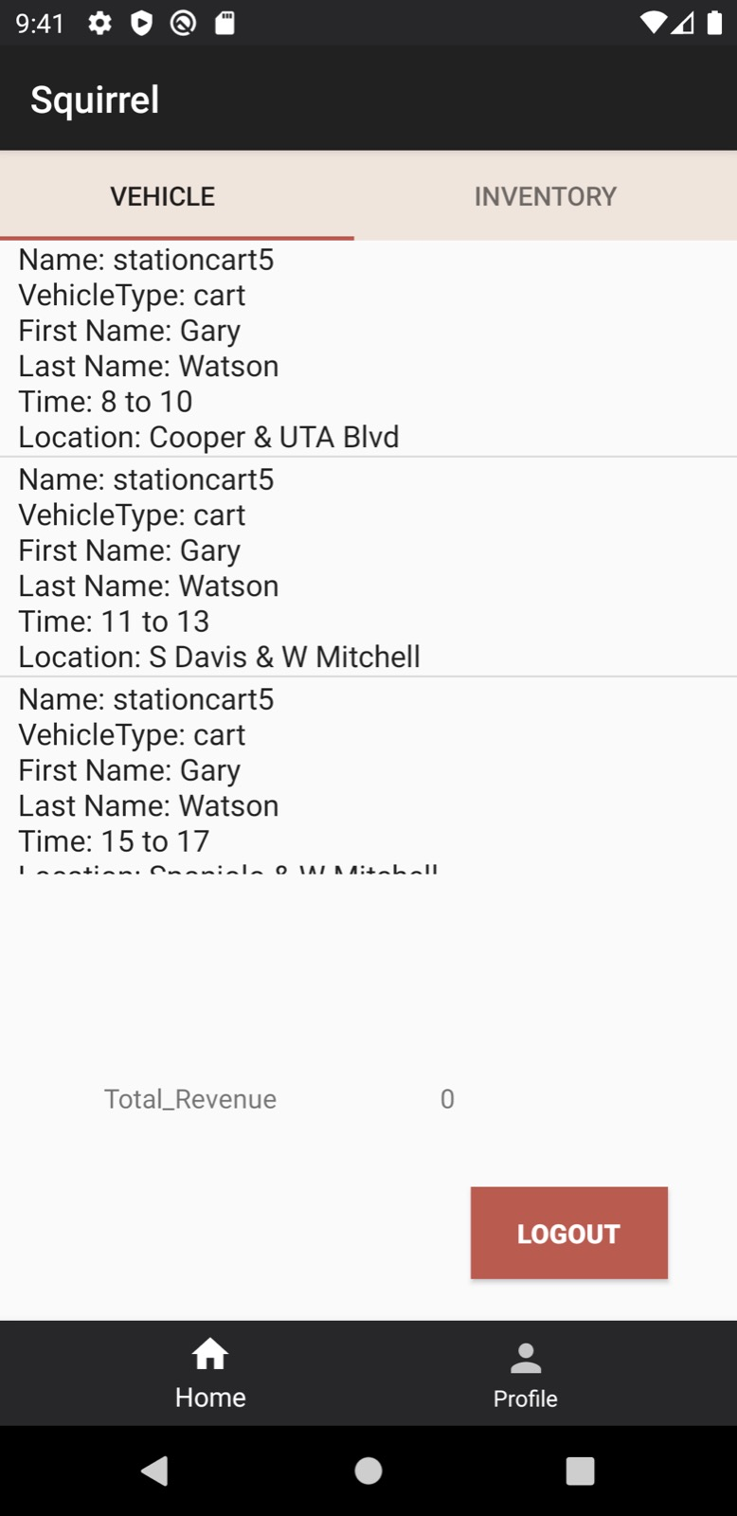

Figure 52